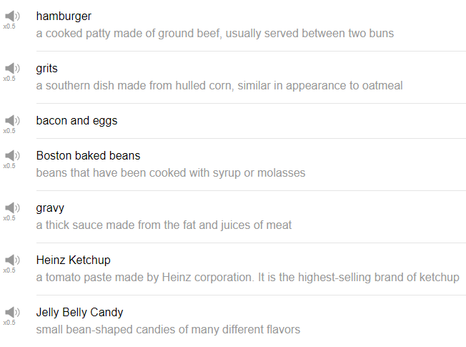

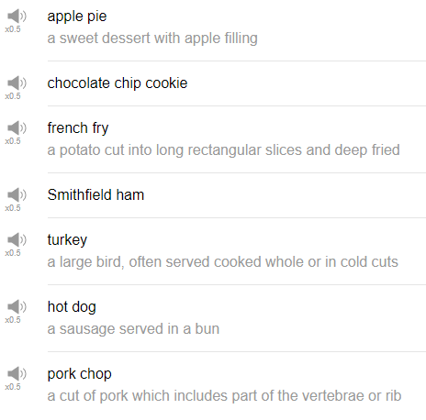

|  |
| --- |
| Hi, everybody! Welcome back to Top Words, my name is Alisha, and today we're going to be talking about American food, so let's get started! |
| 1. Apple pie |
| The first food is apple pie. Apple pie is a delicious and sweet American desert, it is, as it sounds, it is a pie, so a bit of crust, and on the inside is apple, fresh apple, I hope. Large feast often have an apple pie for dessert. In a sentence, my mom cooks an apple pie every Thanksgiving. |
| 2. Chocolate chip cookie |
| Next food is the chocolate chip cookie, this is a very popular cookie, it's a simple cookie, just put chocolate chips into any cookie, into anything, and you can make a chocolate chip cookie. If you eat it there's a very kind of nostalgic childhood feel about a chocolate chip cookie. In a sentence, when I was a child I made chocolate chip cookies with my mom and my brother. That's true. |
| 3. Hamburger |
| The next food is probably the first food you thought of when I said we were talking about American foods today. It is the hamburger, woohoo! A beef patty between two buns, two buns or two pieces of bread, and depending on your preference you can put anything you like on your hamburger. Many people like to use cheese, thereby making it a cheeseburger, you can use lettuce, ketchup, tomato, onion, mustard, relish, whatever go crazy! Bacon, avocado, anything really! I love trying new and interesting hamburger combination! |
| 4. Jellybeans |
| This is an interesting American food, thy are colorful, they usually come in a package about this size, maybe this big. They are kind of a squishy jelly-like candy, very very sugary, and they usually have some kind of fruit flavor. You can find the regular jelly beans, which are sweet and delicious, or you can find jelly beans which are maybe a mysterious mixture. In a sentence, when I was a kid I loved eating jelly beans. This is an actual picture from one of the, from a supermarket, almost all of those are jelly beans, or their candies to some degree. So you can see they're like pins to scoop the candy out of, there is a bin to like pour candy from. This is amazing! American candy is just unreal, there's so much! |
| 5. Turkey |
| Ok the next food is turkey. Turkey is a weird big bird that we almost always eat at Thanksgiving. That's right, turkeys, you're weird! In a sentence, every year my family cooks a turkey for Thanksgiving dinner. |
| 6. Boston baked beans |
| The next food is Boston baked beans, this is something i haven't had in a long time. As you might have guessed, it's an East Coast style food from Boston, so Boston style baked beans are typically sweetened with molasses or with maple syrup. In a sentence, I'm going to make a chili later today with Boston baked beans. |
| 7. Grits |
| This is a food that comes from the southern part of America, I didn't eat grits growing up so I don't really know very well. From a video that we did a while back, we learned that grits are commonly eaten at breakfast, you can eat them with butter. I eat grits every day for breakfast. |
| 8. Hush puppies |
| Here we are again! The next American food is hush puppies. Hush puppies from the same video that we talked about grits, our friend Keith came in and told us about hush puppies. It's just a ball of dough that is fried. That's it a very very simple food, very very healthy, surely, ya know. In a sentence, I haven't had hush puppies yet, and i really want to try them, but they don't seem very healthy, so it's not high on my to-do list. |
| 9. Biscuits and gravy |
| Ok great, the next food is biscuits and gravy. It's a very simple dish as you can guess, it's just a biscuit and gravy, the gravy is usually very very rich, very very fatty, very fattening. This is a dish that is typically eaten for breakfast, a simple coffee shop or just yeah local, a local simple restaurant might have biscuits and gravy on the menu. In a sentence, I used to eat biscuits and gravy at my grandparents house in the winter. |
| 10. Philly cheesesteaks |
| Oh my god! I'm getting so hungry for a very not healthy food. Ok the next food is Philly cheesesteaks, a Philly cheesesteaks are so good. Philly is short for Philadelphia, the city of Philadelphia. Philly cheesesteak is a sandwich from Philadelphia, the sandwich has cheese and steak, oh my god, can you hear my stomach? Delicious! Delicious! It's a very East Coast American sandwich. In a sentence, if you go to Philadelphia make sure you try a Philly cheesesteak sandwich. |
| Alright! So those are 10 American foods. Have you tried any of these foods? What did you think of them? This video has made me very hungry. Alright, thank you very much for watching this episode of Top Words, please make sure to subscribe to our channel if you have not already, and we will see you again soon for some more good information. Bye! |
| Feed me! |